Special Thanks to…

Wisconsin Lutheran High School & Mr. Quinten Petersen - Director of Bands
For our Rehearsal Space
President Dan Lippert
Vice President Marcia Smeiska
Secretary Dave Pauly
Treasurer Mary Wilde

And all our Band Members,
Spouses and Families!

We appreciate your donations (we are a registered nonprofit organization), which will be used to help continue building our library of music, renting rehearsal space and concert halls, purchasing equipment, printing programs, and sending out mailings to you - our audience!

If you play an instrument and are interested in joining the band, please contact our conductor for more information at karenmlippert@gmail.com

Thank You for Your Attendance Today!

Check out our Website at Mmccband.org

Future Concert – Mark Your Calendars:
Memorial Day – Monday May 29, 2023 @ 2PM
Venue TBD

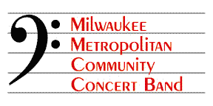
Directed by Karen Mary Lippert
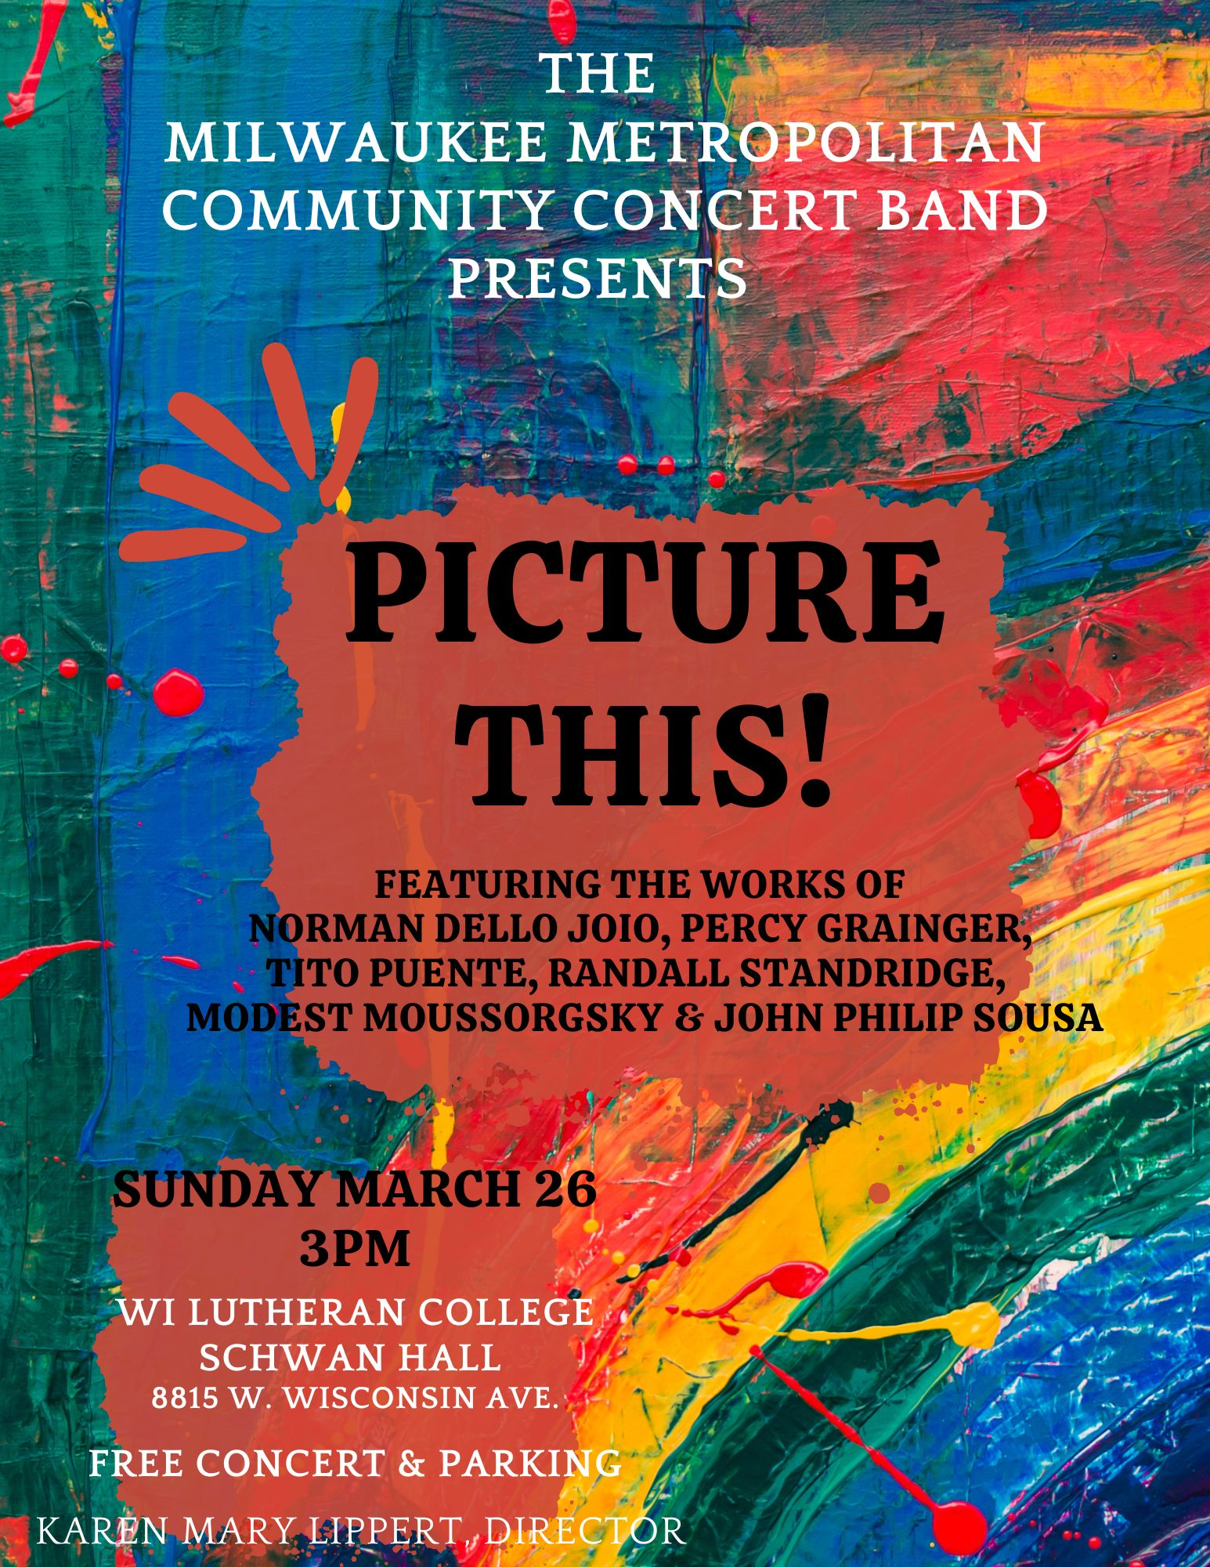

Picture This!

The Star Spangled Banner – A Symphonic Portrait John Stafford Smith Setting by James Swearingen
Piccolo  Dave Pauly  Holly Whitehead  Flute  Gretchen Barg  Rita Becker  Samantha Bronson  Annie Carani  Mary Jackson  Maddalena Paglia  Dave Pauly  CJ Reise  Beth Schroeder  Elaine Wendt  Holly Whitehead  Oboe  Marcia Smeiska  English Horn  Marcia Smeiska  Bassoon  Brittany McCorriston  Clarinet  Justin Bant  Grant Brooks  Ali Moore  Tim Mutterer  Becky Rehborg  Michelle Streed  Mary Wilde  Bass Clarinet  Sherry Dummert | Alto Saxophone  Gabby Baker  Mary Boyd  Brandon Radke  Dan Sprague  Tenor Saxophone  Joyce Gardiner  Tracy Jaeckel  Baritone Saxophone  Andy Stockhausen  Trumpet  Gillian Anunson  Jackie Gerhardson  Gary Kilvinger  Nancy Pearson  Paul Pichler  Dan Russell  Jim Russell  John Schram  Mark Schroeder  Joseph Schueller  Angela Schulz  Matt Ubell  French Horn  Ferd Bahr  Rhea Geschke  Mallory Hanson  Judy Keene  Jennifer Norris  Jan Schuldt  Katie Shoemaker  Mark Struve | Trombone  Patrick Graham  John Jaeckel  Sean Karth  Dean Pearson  Dave Starcic  Dale Ziegler  Euphonium  Dan Odya  Jim Rundel  Bruce Schram  Tuba  Don Kirst  Ryan Schroeder  Andrew Tollefson  Percussion  Erik Alexander  Robyn Bennett  Renee Couture  Edward Dold  Dan Lippert  John Schueller  Matt Ubell

Pictures at an Exhibition
Modest Moussorgsky
Promenade
The Old Castle
Tuileries
Bydlo
Ballet of the Unhatched Chicks
The Great Gate of Kiev

The Clapping Song
Randall D. Standridge

To Soar with Broken Wings
Tyler Acari

Homestretch Galop
Karl L. King Arranged by Gene Milford

15 Minute Cookies & Milk Intermission

The Milwaukee Metropolitan Community Concert Band

Walking Tune
Percy Grainger Arranged by Robert Sheldon

Scenes from “The Louvre”
based on Ancient Airs
Norman Dello Joio Arranged by Robert Longfield

The Portals

Children’s Gallery

The Kings of France

The Nativity Paintings

Finale

Niagara Falls
Adrian B. Sims
Alligator Alley
Michael Daugherty

The Triton March
John Philip Sousa



The Milwaukee Metropolitan Community Concert Band was incorporated in 1994 as a nonprofit corporation with the mission to bring quality music to the greater Milwaukee area and to offer an enjoyable music experience for community musicians while developing their musical talents.
The band performs several times a year in concert as well as playing on their band wagon in parades during the month of July.
Our Conductor

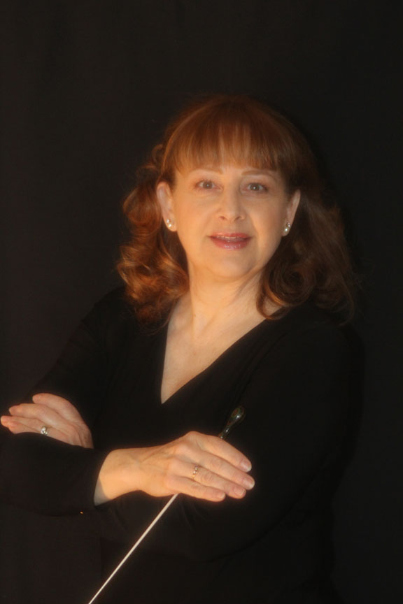
Principal Conductor Karen Mary Lippert

Ms. Lippert is a recipient of the Civic Music Association of Milwaukee certificate of Excellence in Music Education. She is a member of the Wisconsin Music Educators Association and is an inductee into the American School Band Directors’ Association. She is founder and band director celebrating more than thirty-five years at St. John’s Lutheran School – Lannon. She also serves as the bell choir director of the Ringers of Faith – Sussex. She holds a Masters degree in Education and Administration from the University of Wisconsin – Milwaukee. Another musical couple, Karen and Dan (percussionist) met while in the University of Wisconsin - Milwaukee Band and the Milwaukee Knights Band.

